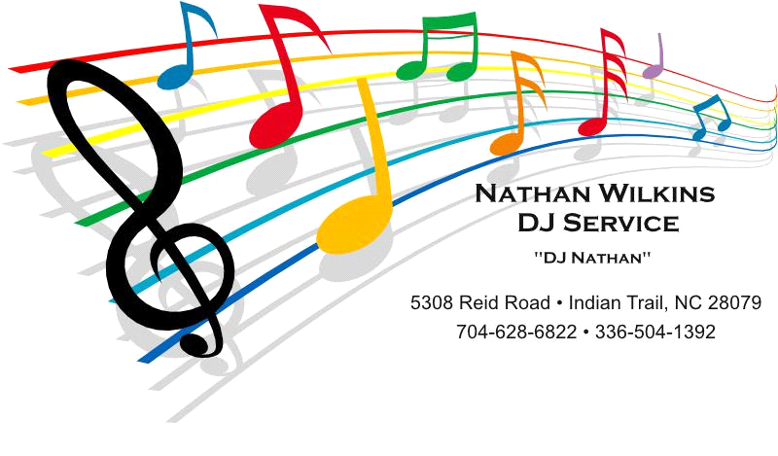
Wedding Reception Schedule
Announce Wedding Party:
Any Grandparents? (Suggest that they already be seated)
- Do You Want A Special Song For Introducing The Wedding Party?

Parents of Bride- Names
Parents of Groom- Names
Bridesmaid- Name esc. by Groomsman- Name
Bridesmaid- Name esc. by Groomsman- Name
Maid/Matron of Honor- Name esc. By Groomsman- Name

- Do you want a special song for introducing the bride & groom or same song ?
Bride & Groom- How do you want to be announced? Also, do you want to dismiss the wedding party?

First Dance Song-Artist & Song Title

Welcome (option) customarily Father of Bride

Bless Food- Person offering blessing. If it’s the officiant, need their name & title.

Culinary Serving Arrangements -DJ to explain the serving arrangements. A buffet meal will be served. All guests are asked to remain seated until their table is requested to proceed to the buffet. This serving arrangement can be modified in any way that the client prefers to suit their needs.

Cut Cake- Discuss Cake Cutting Options.(Traditional or Fun Way)
Toast- Champagne involved? Also need the names of persons doing initial toast.

Bride/ Father Dance- Artist & Song Title
Groom/ Mother Dance- Artist & Song Title

Anniversary Dance- (Optional)

Wedding Shoe Game- (Optional)

Dollar Dance- (Optional)

Bouquet Toss-Special Song?

Garter Ceremony-Special Song?

Last Dance Song- (discuss how the reception ending will be handled)

Party Music-Let’s discuss the types of music or genres that you would like played as well as the music that you do not want played. Generally I play a mix of songs from the 60’s, 70’s, 80’s, 90’s. I also use Country, Urban/Pop Culture, Beach, Classic Rock & Old Rock N Roll. I DO NOT play any RAP music.
Requested Play List From Bride & Groom (8 to 12 songs)
Request Book For Guests
Do You Have A Problem With The Latest Line Dances?(Cupid Shuffle, Wobble etc:)

